SVCR GOVERNMENT DEGREE COLLEGE
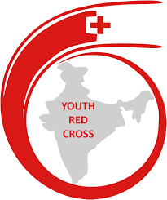
PALAMANER

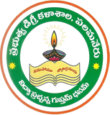

RRC & YRC REPORT
2025-2026

SVCR GOVERNMENT DEGREE COLLEGE
PALAMANER
RED RIBBON CLUB&YOUTH RED CROSS

S.No | Date | Name of the Activity
1 | 27.11.2025 | POSTER MAKING COMPETITIONS
2 | 01.12.2025 | AWARENESS RALLY ON AIDS

SVCR GOVT DEGREE COLLEGE
PALAMANER
RED RIBBON CLUB&YOUTH RED CROSS
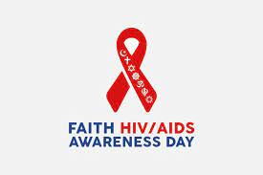

PROGRAM NAME: AWARENESS PROGRAMME ON AIDS AND RALLY
PROGRAM DATE: 01.12.2025
TIME: 11.00 AM
VENUE: SEMINAR HALL
RESOURCE PERSON: RRC,NCC&NSS
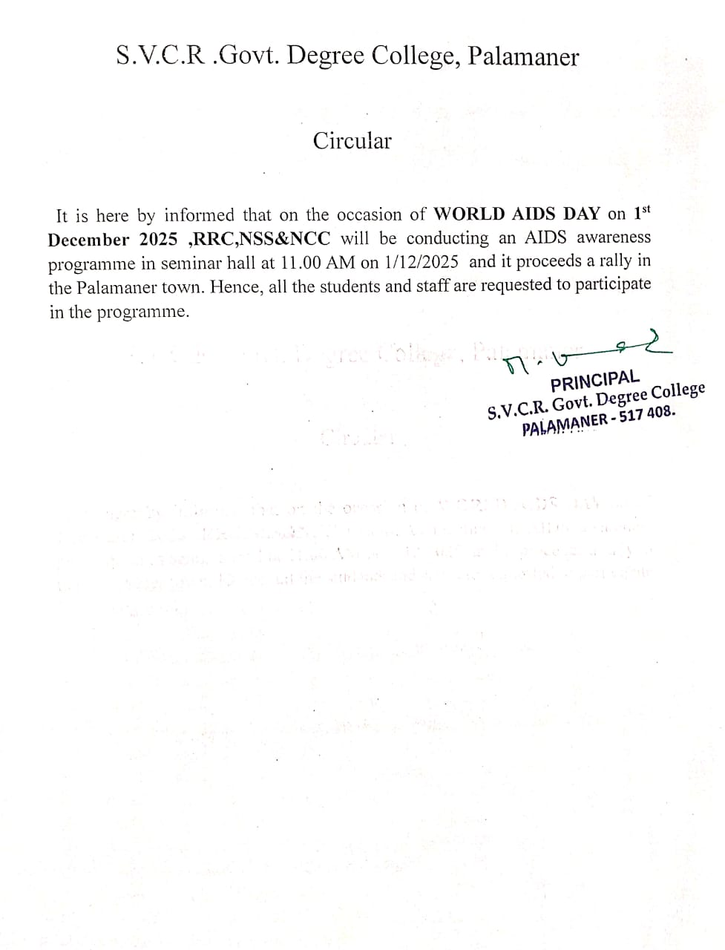

OBJECTIVES OF THE PROGRAMME:
1. To educate the citizens of the town on the deadly disease HIV AIDS.
2. To promote an environment for a healthy society by the students
3.The objective of the program is to educate the citizens of the town on the deadly disease HIV AIDS.
4.To promote an environment for a healthy society by the students.
REPORT OF THE PROGRAMME:
AIDS awareness Programme was organized by the RRC,NSS&NCC units of the college on 1/12/2025. Resource persons spoken about AIDS causes, Prevention and treatment. Prizes were distributed to students who participated in poster making competitions conducted on 27/11/2025. NSS volunteers and NCC Cadets and students participated in AIDS Awareness rally from College to Ambedkar circle , Palamaner town. This rally was aimed to create awareness about Causes and Preventive measures of HIV/AIDS. This rally was also intended in demolishing the various myths that go around in the society about the spreading of AIDS Totally 128 students and 17 faculties participated in rally.

OUT COME:
1.The students participated in the rally and sensitized the uneducated citizens on the deadly effects of the disease HIV AIDS.
2.Programme promote safer sex practices and encourage the use of sterile needles and other preventative measures to reduce new infections.

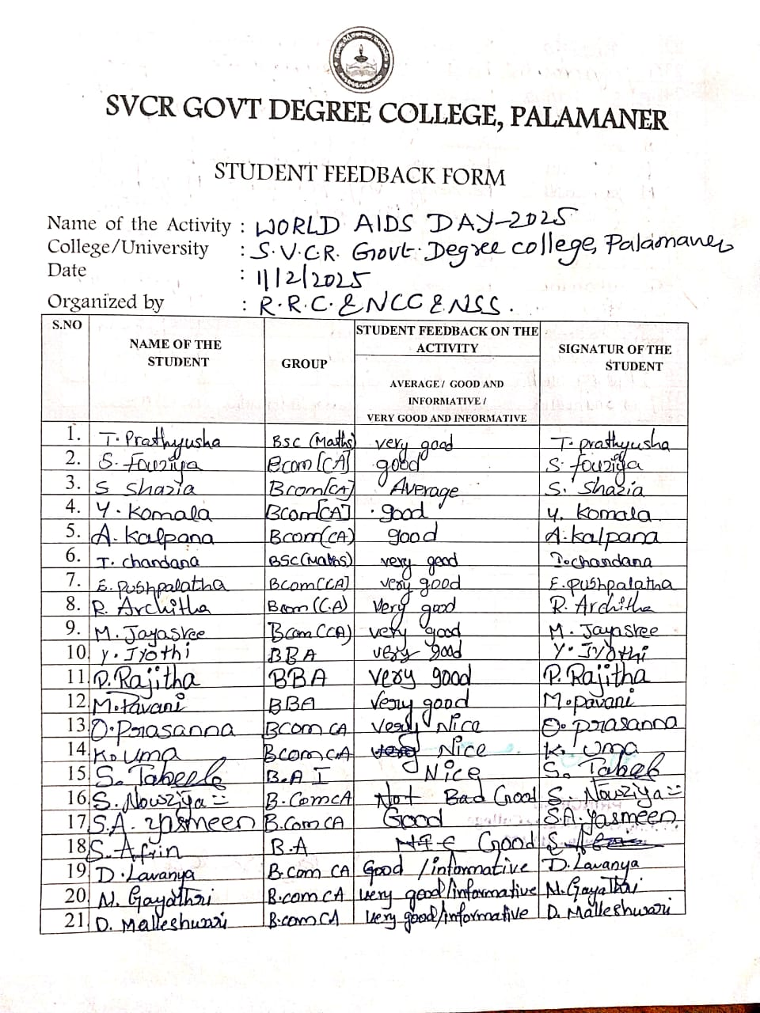

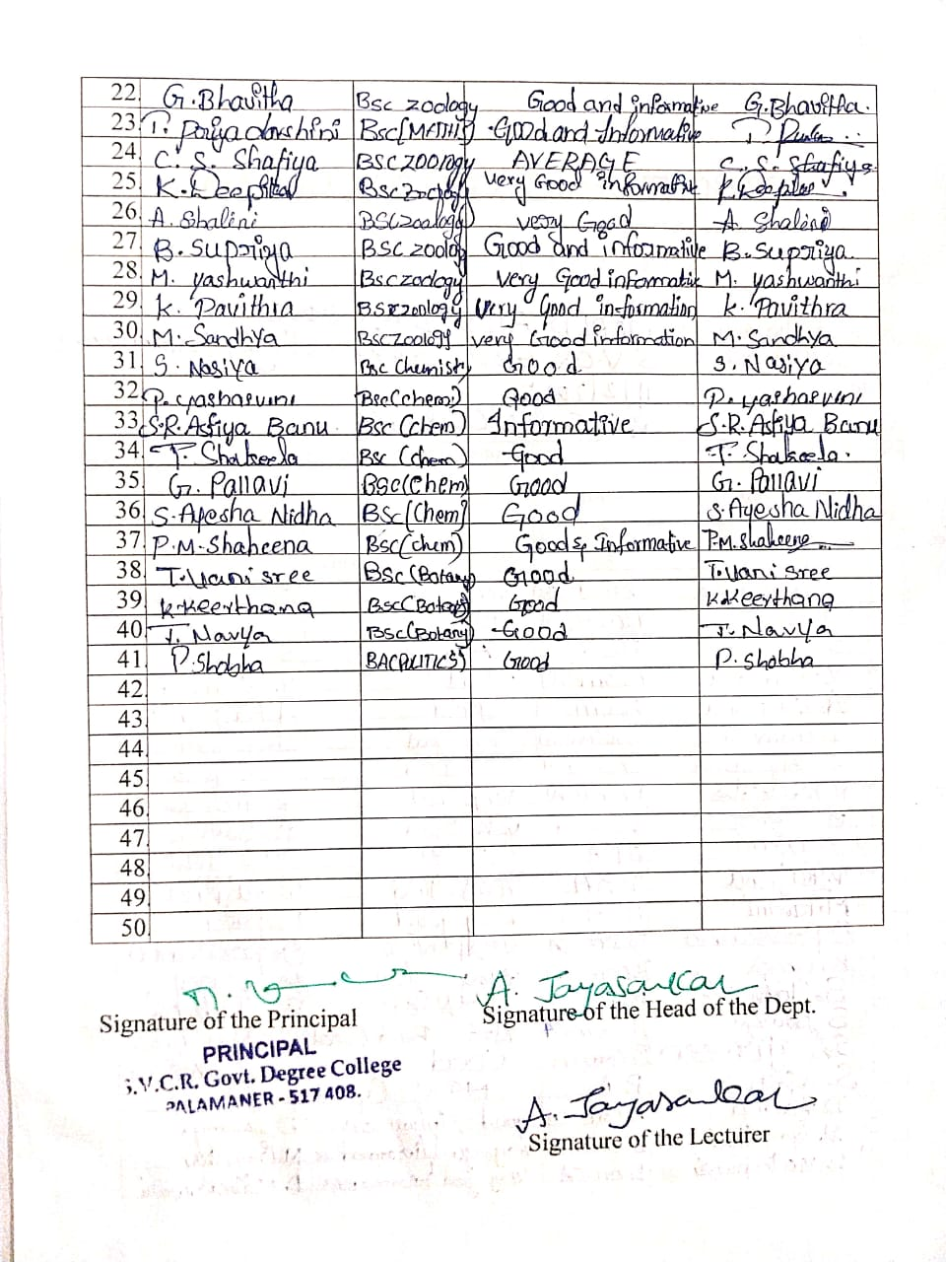
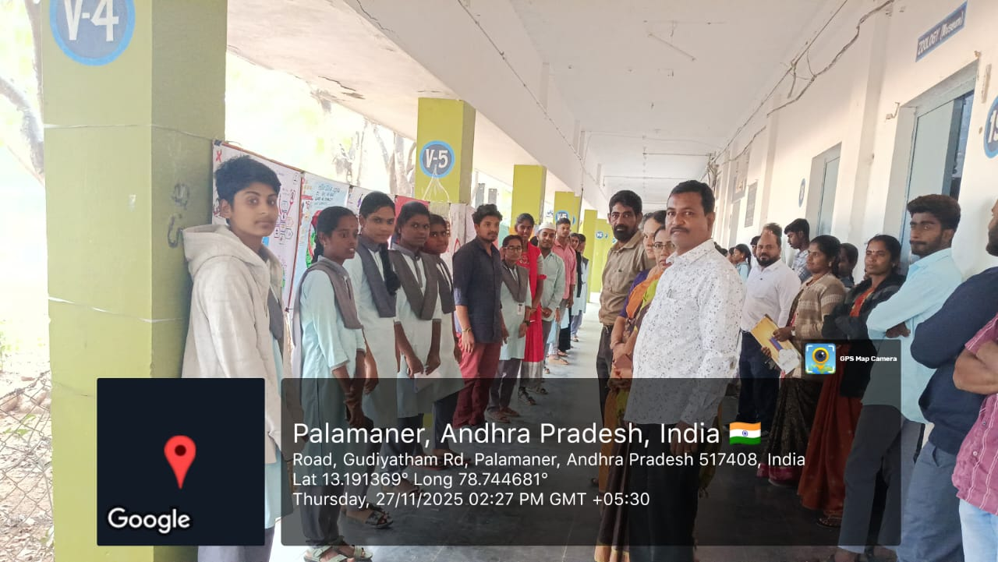
Poster Making Competitions on 27/11/2025
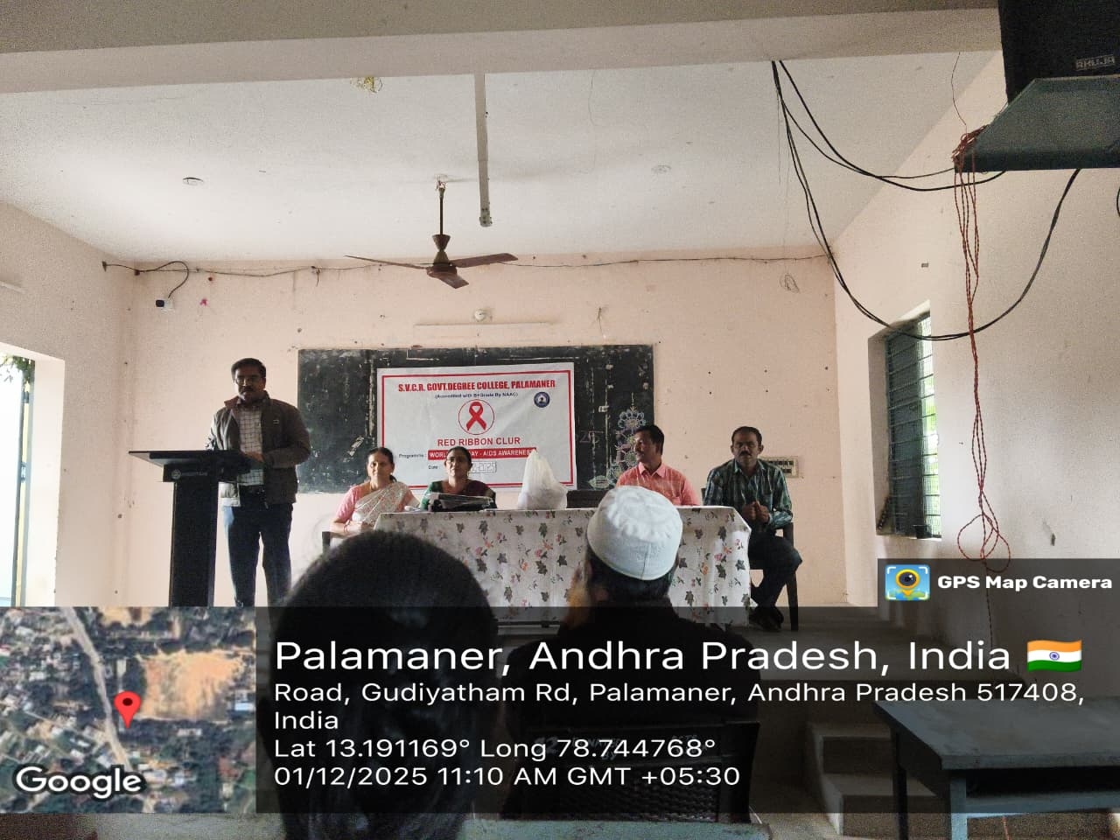
The Vice Principal Dr.K.Nandeeswariah garu given a speech on causes and prevention of AIDS.

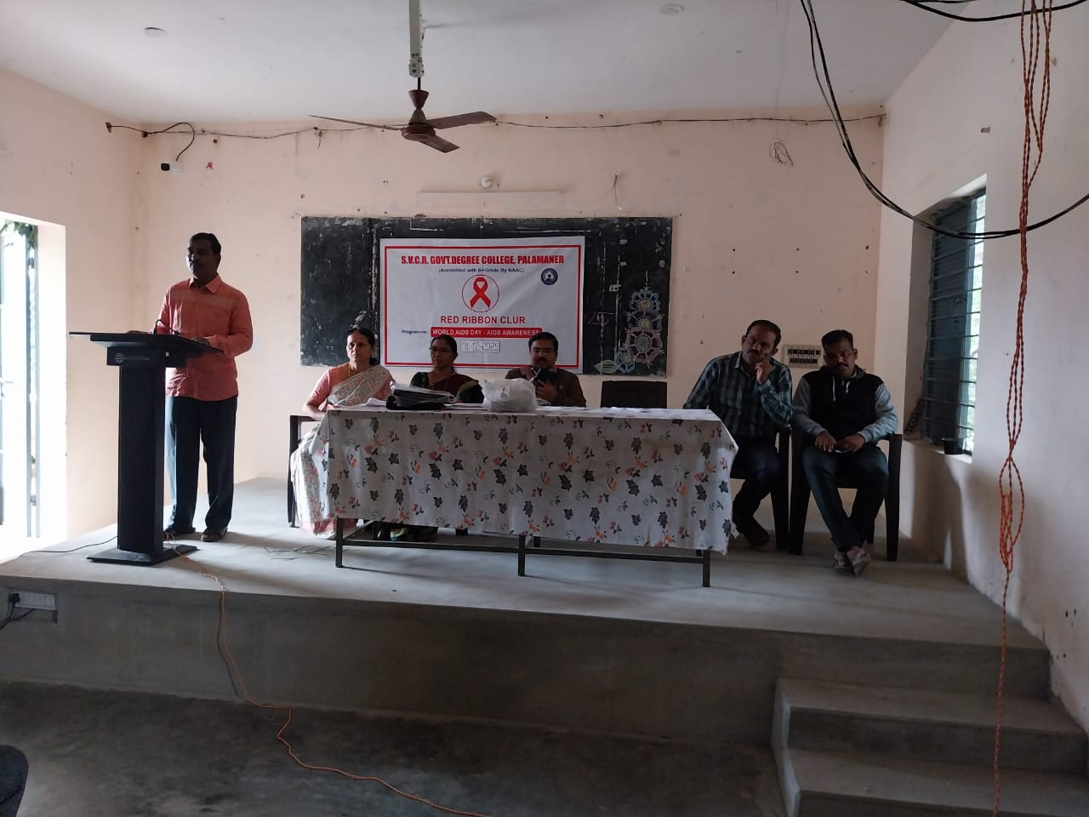
Red ribbon club Coordinator Dr.A.Jayasankar given a speech on AIDS disease causes,prevention and controlling measures.

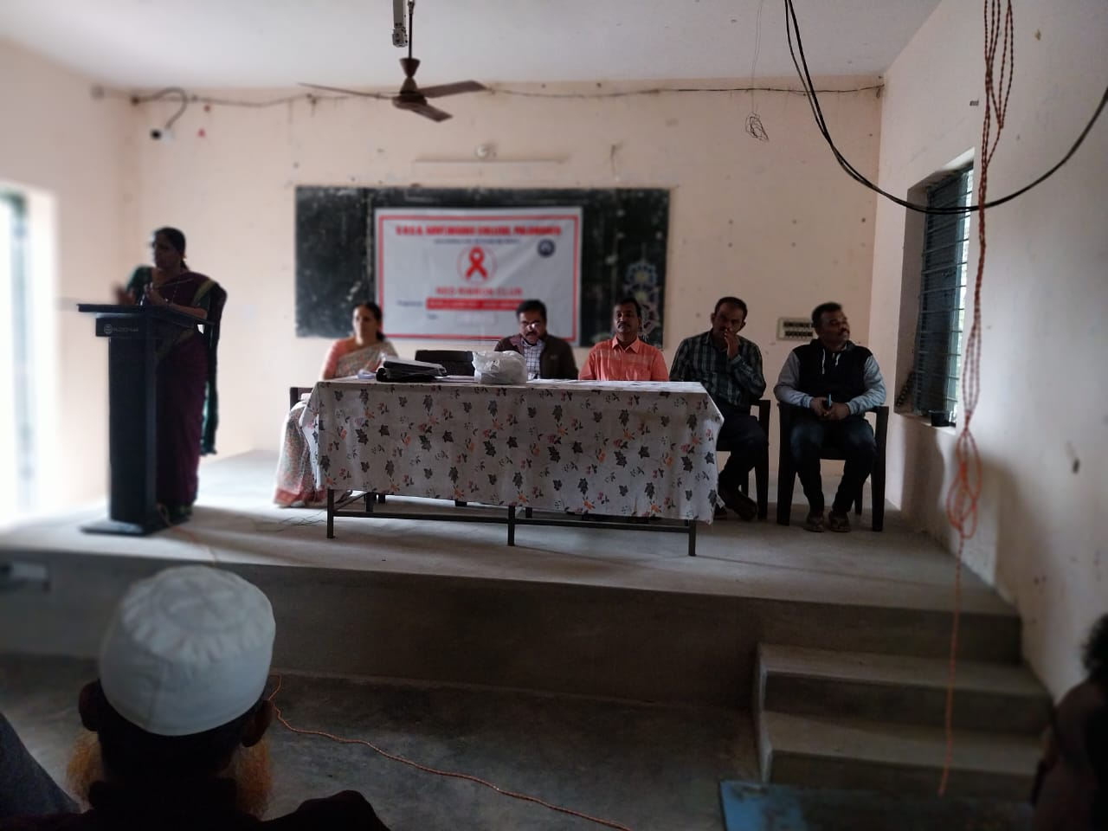
IQAC Coordinator Dr. Shaik Benazeer speaking about AIDS Prevention and treatment

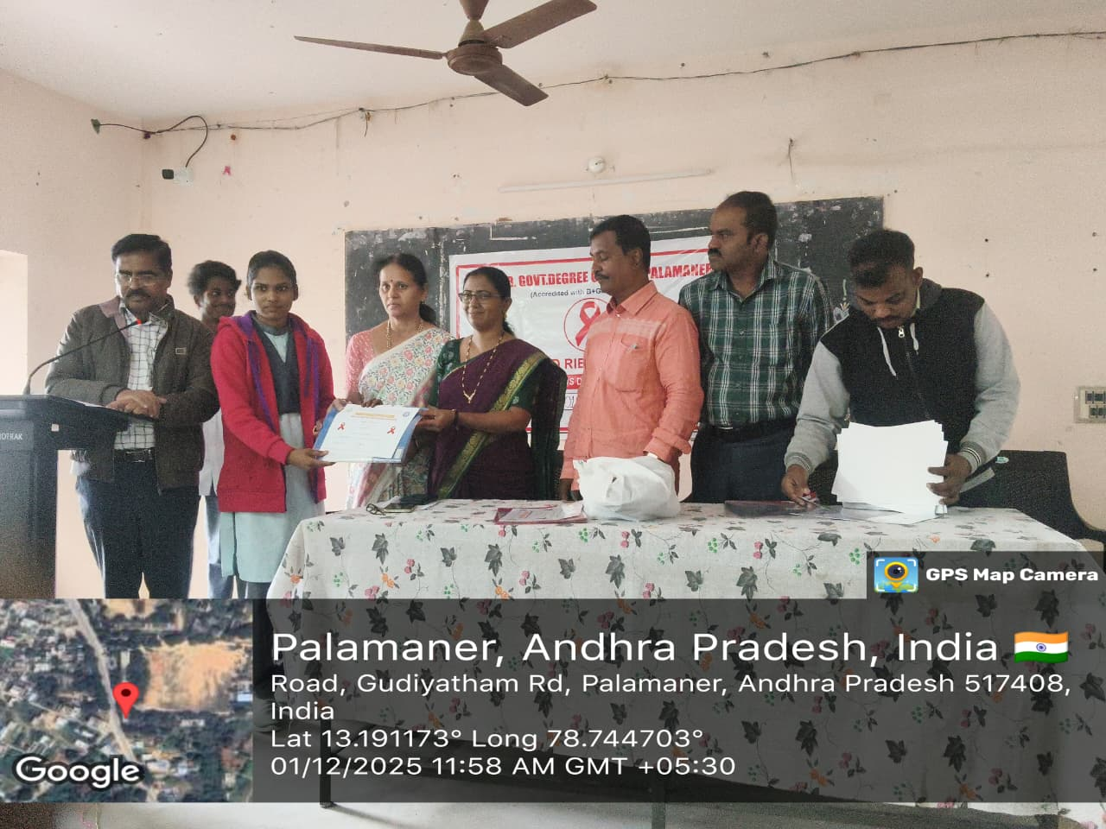
Prize distribution by the Vice- Principal, IQAC, RRC, WEC Coordinators
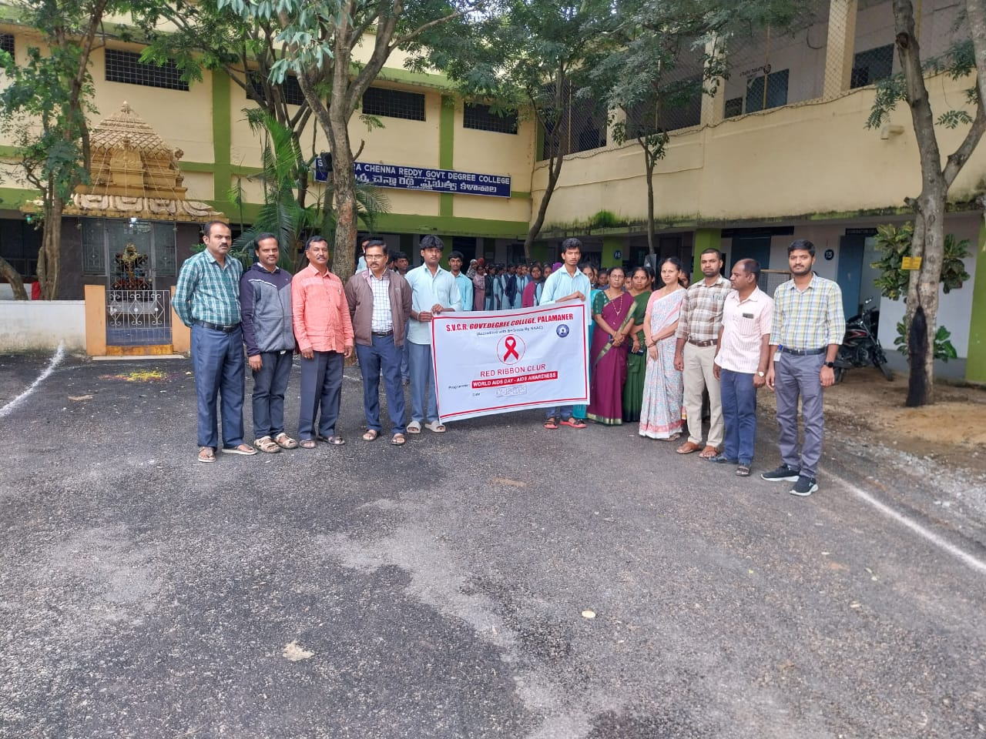
RRC,NSS and NCC students conducted Aids Awareness rally in Palamaner town on 1/12/2025

NEWS PAPER CLIPPINGS

